**100 Books To Try And Read In Year 3 and 4 Page 4 of 5**

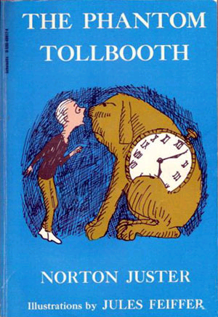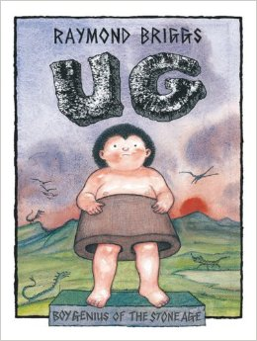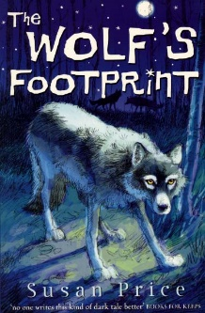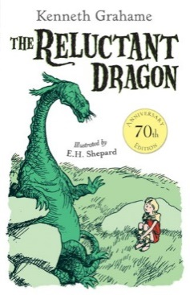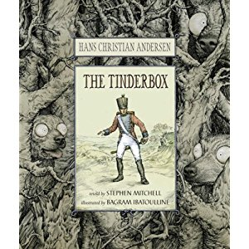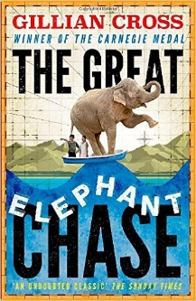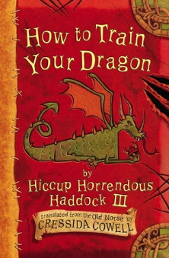

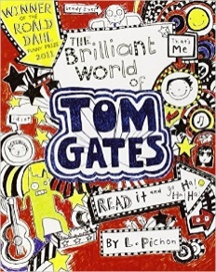

A World of Information

Richard Platt

Tales Of A Fourth Grade Nothing

Judy Blume

The Boy Who Biked The World

Alastair Humphreys

I Am Not A Loser

The Cat In The Hat

Dr Seuss

The Sandwich Thief

Andre Marois

Fantastically Great Women Who Changed The World

Kate Pankhurst

The Sticky Witch

Hillary Mckay

The Reluctant Dragon

Kenneth Grahame

The Moonshine Dragon

Cornelia Funke

The Brilliant World of Tom Gates

Liz Pichon

Liz Pichon

Secrets According to Humphrey

Betty G. Birney

The Adventures of Captain Underpants

Dav Pilkey

You’re A Bad Man Mr Gum!

Andy Stanton

Erica’s Elephant

Sylvia Bishop

The Phantom Tollbooth

Norton Juster

How to Train Your Dragon

Cressida Cowell

The Wolf’s Footprint

Susan Price

The Tinderbox

Hans Christian Andersen

Ug: Boy Genius of the Stone Age

Raymond Briggs

The Great Elephant Chase  
  
Gillian Cross

