**100 Books To Read In Year 5 and 6 Page 3 of 5**

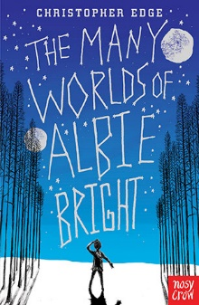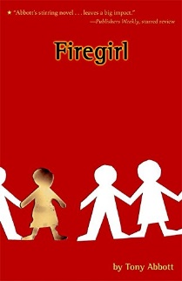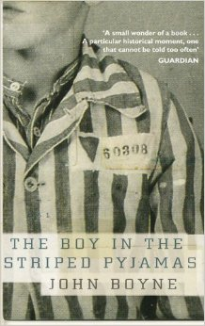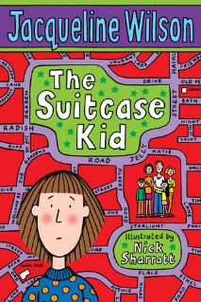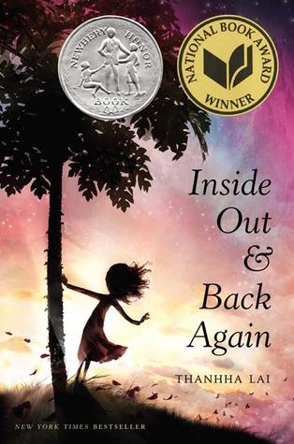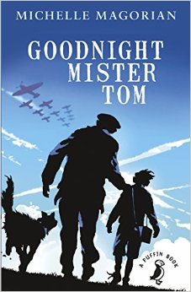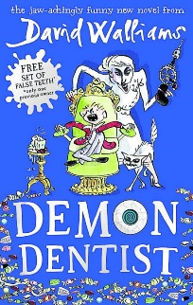

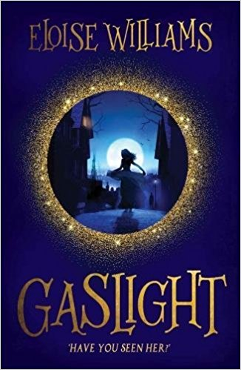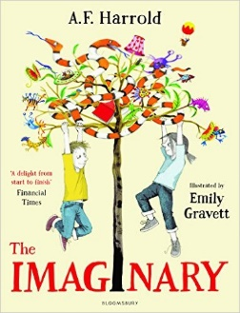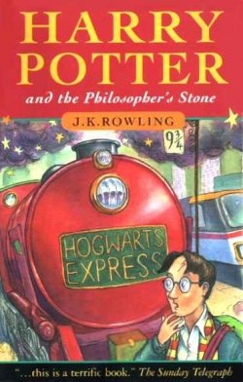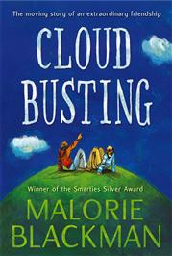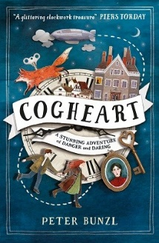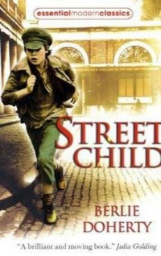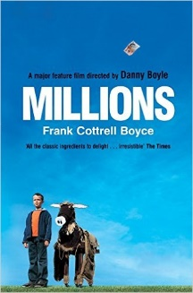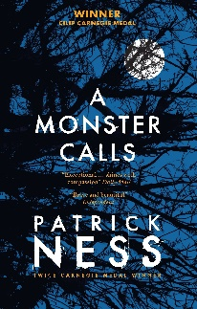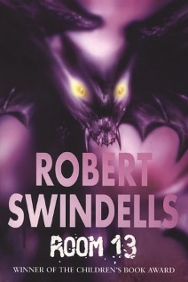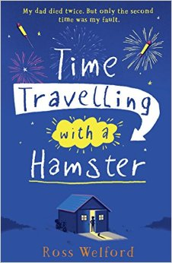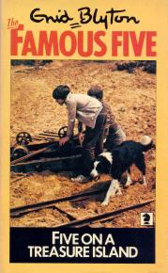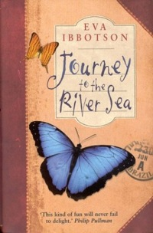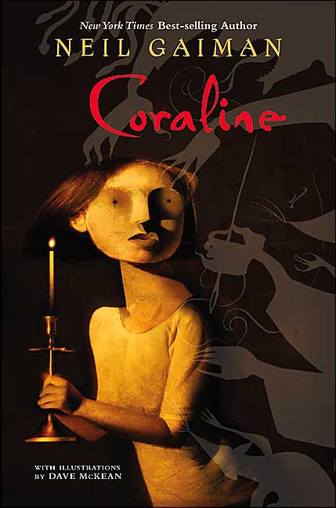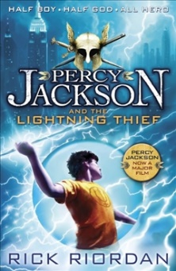v

Five On A Treasure Island

Enid Blyton

The Imaginary

A F Harold

Harry Potter and the Philosopher’s Stone

JK Rowling

Gaslight

Eloise Williams

Cloud Busting

Malorie Blackman

Cogheart

Peter Bunzl

Street Child

Berlie Doherty

Millions

Frank Cottrell-Boyce

Inside Out and Back Again

Thannha Lai

A Monster Calls  
Patrick Ness

Room 13

Robert Swindells

Time Travelling With a Hamster

Ross Welford

Journey to the River Sea

Eva Ibbotson

Coraline

Neil Gaiman

Percy Jackson and the Lightning Thief

Rick Riordan

The Many Worlds of Albie Bright

Christopher Edge

Firegirl

Tony Abbott

The Boy in the Striped Pajamas

John Boyne

The Suitcase Kid

Jacqueline Wilson

Goodnight Mister Tom

Michelle Magorian

Demon Dentist

David Walliams