**“All pupils show a real thirst for knowledge and love of all that they learn.” OFSTED 2015**

**A Letter from the Acting Headteacher**

On behalf of the staff and governors, I would like to welcome you to our school community.

At Paulton Junior School, we endeavour to provide a safe, secure and stimulating learning environment, where children can thrive. Our caring ethos is due to the strong relationships that exist between the children, parents and staff. We pride ourselves on providing opportunities to support and develop each child personally, morally, socially and academically.

Our dedicated staff team work hard, resulting in high standards of learning and behaviour. They ensure that the broad and balanced curriculum is engaging, builds children’s confidence and a lifelong love of learning. In addition, it is important to promote the school values, which nurture self-belief, independence, responsibility, resilience and respect for others.

To meet these aims, we offer a full range of core and foundation subjects, together with enriching elements. For example, in the past year the children have had History enrichment days based on the Vikings, Romans and Stone Age, Art days, Bikeability, whole class ukulele or Djembe drum lessons, a Year 6 residential, Forest school, lunch and after-school clubs, Young Voices choir.

I would like to thank you for choosing Paulton Junior School and hope that you will be happy with us for the next four years. All the staff look forward to working with you, to provide wonderful memories and achievements for your child that can be celebrated in years to come.

Yours sincerely,

**Mrs. Sally Rawlings**

Acting Headteacher

|  |  |
| --- | --- |
| **Role** | **Name** |
| **Acting Headteacher**  **Designated Safeguarding Lead (DSL)** | Mrs Sally Rawlings |
| **Acting Deputy Headteacher**  **Deputy Designated Safeguarding Lead (DDSL)** | Mrs Victoria Langan |
| **Senior Leadership Team (SLT)**  **And DDSL** | Mr Joe Barge  Mrs Joanne Chapman |
| **Full Time Teachers** | Mr Joe Barge  Mrs Joanne Chapman  Miss Katy Burke  Miss Natasha Richards  Mr Robin Smith  Miss Amy Russett  Mrs Rebecca Curtis  Miss Fiona Walker  Mrs Laura Waterhouse  Miss Aimee Reynolds |
| **Part-Time Teachers** | Mrs Sophie Pearson  Mrs Tracey Mallon  Mrs Kathryn Goucher  Mrs Katherine Walker  Mrs Sarah Suchecki  Mrs Laura Truelove (Maternity)  Mr Nathan Newland |
| **SENCO** | Mrs Elaine Weaver |
| **School Secretary** | Mrs Bernie Pratten |
| **Admin Assistants** | Mrs Hannah Green |
| **Finance Officer** | Mrs Sharon Maundrill |
| **Teaching Assistants** | Mrs Teresa Redwood  Mrs Melissa Craven  Mrs Ali McLachlan  Mrs Jacqui Grainger  Mrs Katie Jones  Mrs Ann Squires  Mrs Sarah Norman  Mrs Denise Shenton  Miss Kayleigh Dainton  Mrs Charlene Rowlands  Mrs Carla Davies |
| **Teacher’s PA** | Mrs Haley Shackleton |
| **SMSA Team** | Mrs Carla Davies  Mrs Hannah Green  Mrs Charlene Rowlands  Mrs Vicky Ferris  Mrs Paige Miles  Mrs Jenny Frankham  Mrs Denise Shenton  Mrs Mel Craven |
| **Cleaning Team** | Mrs Sandra Ryder  Mrs Bev Horler  Mrs Tracey Price  Mrs Sue Miles |
| **Caretaker** | Mr Matt Dowling |

**THE GOVERNING BODY**

Governors have wide ranging responsibilities including: -

* The overview of the school curriculum.
* Appointment of staff.
* Upkeep of school buildings.
* Monitoring of School finances.

The full governing body of each school meets at least once per term. There are sub- Committees for Curriculum, Finance & Personnel and Premises/Health & Safety. At present, the Governing Body comprises up to 12 members, variously appointed by the Local Authority, staff, parents and co-optations from the local community.

**The members of the Junior School Governing Body are -**

Mr Simon Memory - Chairperson

Mr John Harvey

Mr Joseph Barge

Mrs Sarah Johnson

Mr Grant Johnson

Mrs Kate Higgs

Mrs Lindsey Baker

Mrs Sally Rawlings

Mr M Grosvenor

Mr Mike Birch

Clerk to Governors – vacant position

**PAULTON SCHOOLS**

Paulton Schools have served the local community for well over 100 years, the Junior School moving to its present site in 1972 and the adjacent Infant School two years later. Paulton Junior School enjoys extensive grounds comprising a playing field and surfaced play areas. The children throughout the year to support their studies use the area widely. A covered heated swimming pool is situated next to the site and all children have swimming lessons throughout the year.



Paulton Infants' School is part of the Bath & Mendip Partnership Trust and Paulton Junior School is entirely independent. Each school has its own Headteacher and Governing Body. However, the Governors and staff are totally committed to the notion of education as a continuum - beginning at home and progressing from phase to phase with planned continuity. Both schools are committed to liaise with each other to ensure for the best outcomes for our children. The Infant School fosters strong links with home and local playgroups. The Junior School liaises with all local secondary schools and special schools.

**The Junior School** caters for 360 children between the ages of seven and eleven (Key Stage 2 - Year 3, Year 4, Year 5, Year 6). The school is currently divided into 12 classes.

Children transfer to Secondary Education in the September following their eleventh birthday. Details regarding this transfer are sent out during the final year at Junior School. Children usually go on to Somervale, Norton Hill or Writhlington Secondary Schools.

The admission level for the Junior School is 90. Class sizes presently vary between 22 and 26 depending on the size of the year group. Infant classes do not exceed 30 at any time.

The time spent on teaching during a normal week is 23 hours 30 minutes for junior aged children. For infant aged children the teaching time is 22 hours. This excludes Collective Worship, registrations and break times.

**THE AIMS OF PAULTON JUNIOR SCHOOL**

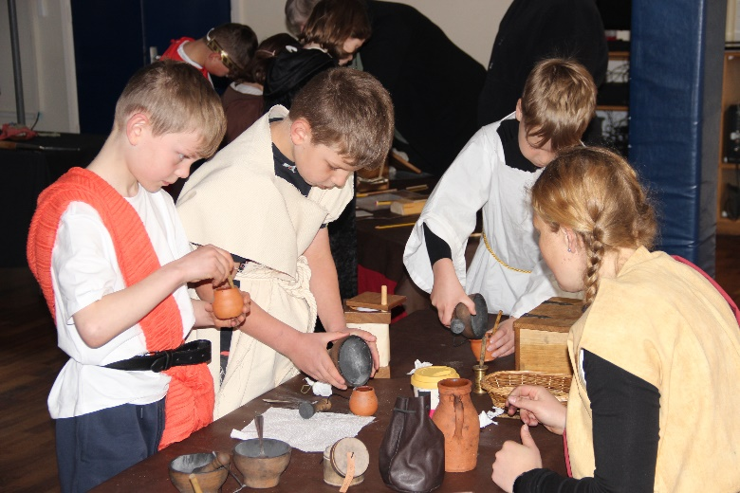

Children, their needs and interests, are at the heart of school communities. Whilst there are features in educational provision and school buildings which are common to all schools, individual establishments have a unique nature. This uniqueness is to be found in the people - children and adults - who work there, and in the care and respect they show each other, in their attitude to the tasks they perform, and what they see as valuable. The actions and attitudes of each member of the community - child and adult - affect the quality of life within the school, the achievement of its aims, and the effectiveness of its work.

Our school offers each child a broad general education, developing individual skills and talents so that every child may achieve the best of which he or she is capable. At the same time, we aim to give the children a strong and clear sense of their own worth. We create a sympathetic climate, which allows everyone within our school to celebrate the success of others and provide caring support when needed. Children are expected, however young, to take the degree of responsibility appropriate to their stage of maturity, for themselves, for others, and for their environment. Within this framework, we aim:-

* To keep children's *learning* at the heart of all our thoughts and actions.
* To provide the opportunity for *all our children to achieve* academic excellence

within a broad and balanced curriculum.

* To create an ethos which nurtures *self-belief*, *independence* and a sense of

*respect* for others

* To ensure that our school is a happy, safe, supportive and secure place

in which to learn.

* To create a *stimulating learning environment*.
* To develop *strong* and *productive partnerships* with parents and the

wider school community

* To have *high expectations* in *all areas* of school life.
* To *prepare children* for the *future* by being *confident individuals* and *responsible citizens.*

**CURRICULUM**

At Paulton Junior School we are committed to providing a happy, safe and stimulating environment in which children can enjoy their learning. We strive to make learning fun and provide an education that develops the whole child academically, socially, physically and emotionally.

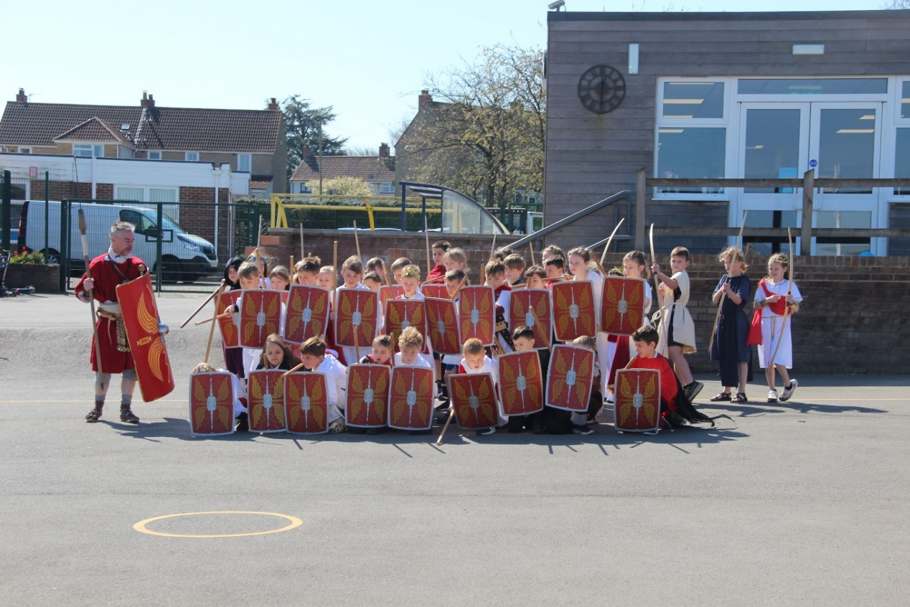

Our curriculum intends to:

* Provide a broad and balanced education for all pupils that’s coherently planned and sequenced towards progression and sufficient knowledge for skills and future learning and employment.
* Enable pupils to develop knowledge, understand concepts and acquire skills, and be able to choose and apply these in relevant situations
* To set challenging expectations of educational standards and achievement which enable pupils to reach high standards of attainment
* To value individuals and provide opportunities that are equal for everyone regardless of race, gender or intellect
* Ensure equal access to learning for all pupils, with high expectations for every pupil and appropriate levels of challenge and support
* Promote a positive attitude towards learning
* To Equip pupils with the knowledge and cultural capital they need to succeed in life and enable children to receive an education that will serve them beyond their primary school experience, by developing the whole child as an individual, encouraging confidence, high self-esteem and independence
* To ensure that the ethos of the school provides a valuable learning experience, where mutual respect and co-operation fosters positive attitudes to work and relationships
* To establish a climate in which children, teachers, parents and governors work together to achieve the best possible education for each and every child.
* To provide 32.5 hours in school per week from September 2023. (8:30am-3:00pm)

In order to adapt to the needs of pupils from the pandemic we have a clear understanding of previous learning for the core subjects from our neighbouring infant school and can revisit these where identified, likewise we aim to offer increased social interaction through Forest School opportunities and provision of extra-curricular clubs.

At the end of the Key Stage in Year 6, children are formally assessed (SATs) in English and Maths and a measure of attainment is provided for each child. However, throughout their education at Paulton Junior School all children are assessed formally and informally. This enables the teacher to plan work accordingly, to ensure children are working to their ability.

Please see an overview of each subject’s curriculum intent. For more information regarding this and our overall curriculum, please see our website.

**ENGLISH**  
At Paulton Junior School we believe that a quality English curriculum should develop children’s love of reading, writing, spelling and discussion. Producing learners who are curious to learn, want to discover more, have a thirst for learning and are life-long learners. We have a rigorous and well organised English curriculum that provides many purposeful opportunities for reading, writing, spelling and discussion. Our overarching aims, which can be located on our website are embedded across our English lessons and the wider curriculum. We will provide the means for children to develop a secure knowledge-base in English, which follows a clear pathway of progression as they advance through the primary curriculum. Rigorous assessment and review will ensure that we are able to provide targeted support so that all children experience success in English; we believe that a secure basis in literacy skills is crucial to a high-quality education and will give our children the tools they need to participate fully as a member of society.

**MATHS**

Mathematics is an essential tool for everyday life. It is a whole network of concepts and relationships which provide a way of viewing and making links and sense of the world. It is used to analyse and communicate information and ideas and to tackle a range of practical tasks and real-life problems. Please see our website for how our curriculum develops pupils as mathematicians.

**SCIENCE**

It is our intention at Paulton Junior School to develop in all young people a lifelong curiosity and interest in the sciences. Our Science curriculum aims to give all children a strong understanding of the world around them whilst acquiring specific skills and knowledge to help them to think scientifically, to gain an understanding of scientific processes and also an understanding of the uses and implications of Science, through history, today and for the future. When planning for the science curriculum, we intend for children to have the opportunity, wherever possible, to learn through varied systematic investigations, leading to them being equipped for life to ask and answer scientific questions about the world they live in. As children progress through the year groups, they build on their skills in working scientifically, as well as on their scientific knowledge, as they develop greater independence in planning and carrying out fair and comparative tests to answer a range of scientific questions. At PJS we ensure that children have a varied, progressive and well-mapped-out science curriculum that provides the opportunity for progression across the full breadth of the science national curriculum for KS2.

**COMPUTING**

All pupils at Paulton Junior School Children will able to develop a wide range of fundamental skills, knowledge and understanding that will actually equip them for the rest of their life. This allows children to apply the fundamental principles and concepts of computer science. They develop analytical problem-solving skills and learn to evaluate and apply information technology. It also enables them to become responsible, competent, confident and creative users of information technology.

**PSHE**

Personal, Social and Health Education and Citizenship, (PSHE and C), is designed to help give pupils the knowledge, skills and attributes they need to keep themselves healthy and safe, and prepare for life and work in modern Britain. (PSHE Association 2017) At Paulton Junior School this means that all our pupils are encouraged to take part in a wide range of activities and experiences across the curriculum as well as being encouraged to participate in extra-curricular activities. Developing skills such as resilience, self-esteem, risk management, teamwork and critical thinking in the context of learning grouped into three key themes. As a result, they are contributing fully to the life of our school and local communities. By the age of 11 pupils will have learned about healthy and unhealthy relationships, health and well-being both mental and physical health, living in the wider world, underpinned by British values of democracy, individual liberty, rule of law, respect and tolerance as well as where to seek help and advice. Please see our website on how we aim to equip our children with the skills to be well-rounded individuals as we strive to prepare our children for secondary school and beyond.

**RE**

At Paulton Junior School, we believe that it is important for all our pupils to learn from and about religion, so that they can understand the world around them. The aim of Religious Education in our school is to help children to acquire and develop knowledge and understanding of Christianity and the other principal religions represented in Great Britain. Our aims are for children to appreciate the way that religious beliefs shape life and human behaviours; to explore their own philosophies and beliefs; to develop the ability to justify and give reasons for their thoughts and enhance their spiritual, moral, cultural, emotional, social and physical development. Religious Education is taught throughout the school in such a way as to reflect the overall aims, values, and philosophy of the school, whilst promoting British values, ensuring that children are aware of their rights and responsibilities as UK citizens. It plays an important role, along with all other curriculum areas, particularly PSHE, in promoting social awareness and understanding in our children. We encourage our pupils to ask questions about the world and to reflect on their own beliefs, values and experiences. Our curriculum is designed to encourage creativity, imagination, enquiry, debate, discussion and independence.

**PE**

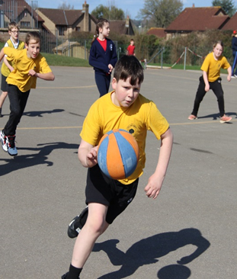PE is a vital part of school life and ultimately children’s future well-being.  It is therefore our intent to provide an inclusive, broad and balanced PE curriculum that ensures ALL children will benefit, whether through enhancing existing skills, learning new skills or being introduced to new sports, clubs, teams and organisations.

It is our intent to ensure children understand the importance of leading a healthy lifestyle and to equip them with the tools to do so through health and well-being education. Children must understand how to take care of themselves both physically and mentally in order to be successful as adults.

Beyond merely a subject, we believe that participation in sporting activity is a key element of developing a school in which pupils are proud of the community in which they belong. Therefore, great emphasis is placed upon additional sporting opportunities beyond the lesson within after-school clubs, inter-house and inter-school competition and festivals as well as directly trying to support the local clubs within the Midsomer Norton area. We believe this links directly with our school’s values of ***Learning together, learning for life*** andis another way in which we can positively engage with our local community and be active citizens within it.

**MUSIC**

At Paulton Junior School all our students deserve a broad and ambitious music curriculum, rich in skills and knowledge, which ignites curiosity and prepares them well for future learning and moreover engenders a lifelong love of music. Music teaching involves a constant revisiting of skills and knowledge. As such, our progression document sets out how these skills are added to and embellished over the 4 years of KS2. To aid teacher assessment and support learning, each term will have a different focus area enabling the teacher to target a specific area of learning which, in turn, gives each child access to a musical education that is both broad and balanced.

**ART**

Paulton Junior School aims to provide all children with a coherent, well-structured and enjoyable education in the Arts, which inspires awe and wonder, a sense of achievement and fosters a curiosity and a voice to comment on their experiences of the world around them. The potential for self-expression and sense of personal achievement in the Arts should be open and obtainable to all children.

**DT**

**“Design is not just what it looks like and feels like. Design is how it works.” Steve Jobs**

Design and Technology is an inspiring, rigorous and practical subject. Using creativity and imagination, pupils design and make products that solve real and relevant problems within a variety of contexts, considering their own and others’ needs, wants and values. The children are also given opportunities to reflect upon and evaluate past and present design technology, its uses and its effectiveness and are encouraged to become innovators and risk-takers.

High-quality design and technology education make an essential contribution to the creativity, culture, wealth and well-being of the nation. At Paulton Junior School, we want to allow children to be exposed to a variety of Design & Technology opportunities to aspire to creating opportunities for them in the wider world. Through the DT curriculum, children should be inspired by engineers, designers, chefs and architects to enable them to create a range of structures, mechanisms, textiles, electrical systems and food products with a real-life purpose. Through the evaluation of past and present design and technology, they develop a critical understanding of its impact on daily life and the wider world.

It is the intent of Paulton Junior School for Design Technology to be taught in all year groups through at least one topic per full term, which includes one topic relating to food every year.

**FRENCH**

‘A high-quality languages education should foster pupils’ curiosity and deepen their understanding of the world. The teaching should enable pupils to express their ideas and thoughts in another language and to understand and respond to its speakers, both in speech and in writing.’ (National Curriculum 2014 – Appendix A)

It is our intent at Paulton Junior School to provide all of our children with a high-quality education in Modern Foreign Languages (MFL), which develops their love of learning languages and other cultures. We currently teach French, however, we strive to provide children with opportunities to experience a range of other languages as well.  The teaching is committed to providing opportunities for the children to communicate for practical purposes; spontaneously and creatively and relevant to their current interests. It is our intention to ensure that by the end of our children’s primary education, they have acquired an understanding of all four skill areas of French, confidence to speak in French with others, feel prepared to transfer successfully to the KS3 Language curriculum as well as have an appreciation of the importance of cultural diversity and traditions.

**GEOGRAPHY**

All pupils at Paulton Junior School will be offered a structure and sequence of lessons from teachers to ensure they have covered the skills required to meet the aims of the national curriculum through Rising Star Geography. The content allows for a broader, deeper understanding of the four areas of geography identified in the curriculum. It will develop contextual knowledge of the location of globally significant places and understanding of the processes that give rise to key physical and human geographical features of the world, along with how they bring about variation and change over time. We intend to develop children’s curiosity and a fascination of the world and its people that will remain with them for the rest of their lives. The units offer a range of opportunities for investigating places around the world as well as physical and human processes. The lessons are intended to improve children’s geographical vocabulary, map skills and geographical facts and provide opportunities for consolidation, challenge and variety to ensure interest and progress in the subject.

**HISTORY**

Rising Stars History provides a history curriculum that is ambitious and designed for all pupils. It is coherently planned and sequenced towards cumulatively providing the necessary knowledge and skills for the pupils’ future to empower them to take their role as informed and active citizens in the 21st century. Its emphasis is not just on historical knowledge but also skills and concepts. It has the same challenging academic ambitions for all pupils. They all work from a shared starting point to answer the same key questions.

The content provides pupils with a clear understanding of how people lived in the past and what they believed to be important. Within the units there are recurring themes such as settlement, migration and religion which builds a stronger web of knowledge to ensure it sticks. Engaging with challenging themes will enable pupils to connect with what is happening in the world around them. It will enable them to engage in debate about what is happening today and use the past to inform those opinions. Over the course of the scheme, pupils will develop an understanding of how we know about the past through a range of sources of evidence and with increasing confidence will consider their utility and reliability. Following the scheme will ensure pupils benefit from a curriculum that enriches their lives and broadens their cultural experiences. This will lead to a better understanding of culture and heritage and a desire to engage further with these areas.

**SWIMMING**

Children in all year groups at Paulton Junior School have the opportunity to take part in swimming lessons. With a pool adjacent to the school it is an opportunity not to be missed. The cost of this is currently met by the school.

**HOMEWORK**

Homework is given regularly to all children. Year 3, 4, 5 and 6 are given spelling activities related to written work, some number work and reading. It is also requested that on occasion work is finished or research completed in preparation for class-based activities. A book is provided for the children to complete their work and a home school reading record is provided. Homework in English, Maths or a Foundation subject is given weekly, on Monday for return on Friday. In addition to this, all classes will be given 'Open Homework Projects' throughout the year. Homework is also displayed on the Year Group page of the website.

**EXTRA CURRICULAR ACTIVITIES**

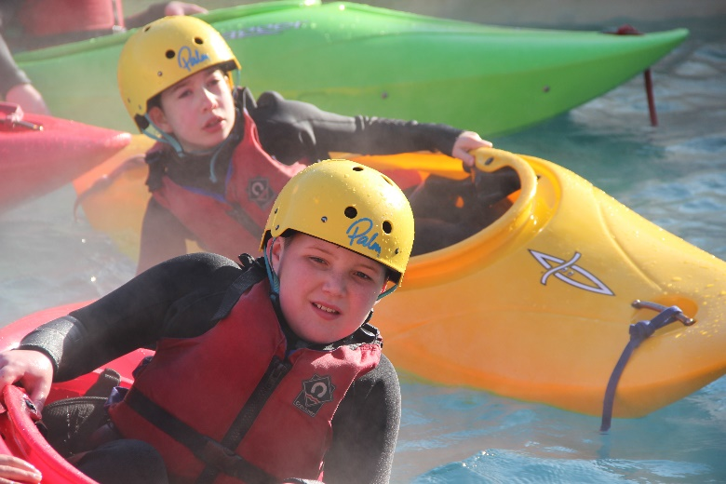

For Junior children there are clubs after school and during the lunchtime break. These clubs reflect the commitment and expertise of the teaching staff and all children are encouraged to take part in these activities. All clubs are free of charge, except where professional coaching is brought into school. Your child will be given the opportunity to sign up to a club in Terms 1 & 2, 3 & 4 and 5 & 6.

**SCHOOL TRIPS AND RESIDENTIALS**

Each year group will have the opportunity to go on trips and visits to enrich their experiences. Year 6 will be given the opportunity to go on a Residential camp.

**THE SCHOOL COUNCIL**

The school has an elected council made up of two children from each class. These children form a council who meet with staff representatives to look at ways of developing the school. Children can make comments and suggestions to their council representatives via class-based suggestions boxes. The school council organises its own fundraising events and is one aspect of the school’s citizenship programme.

**SCHOOL ORGANISATION**

**and GENERAL INFORMATION**

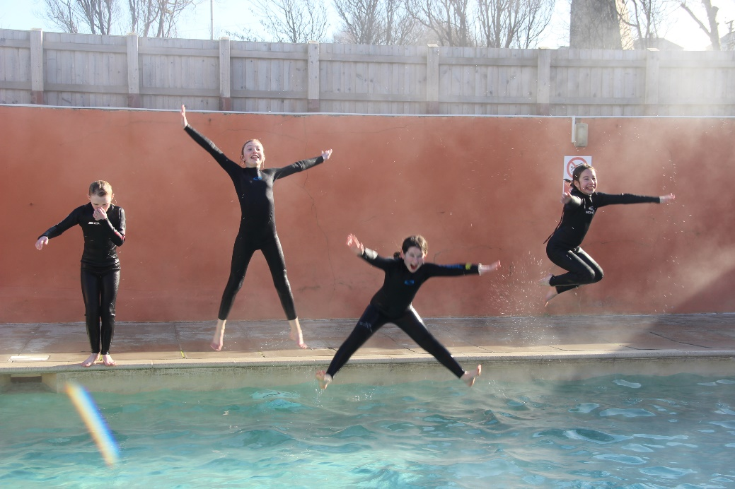

**SCHOOL HOURS**

**The school day begins at 8.30am.** The Lunch break is **12.15pm** to **1.10pm**. **Lessons finish at 3.00pm and children will be dismissed from school after this time.** We cannot take responsibility for any child arriving on site before 8.15am. **We expect children to be punctual for the beginning of the school day**. **Any child arriving late should report to the school office immediately so that we know your child has arrived at school safely.**

**ABSENCE**

**If your child needs to be absent from school, please let the school office staff know the reason on the first day of absence by 9.00am**. **To ensure complete continuity** **please do not give absence messages to any other members of staff/teaching staff.** **You can leave a message on the school answer phone 24 hours.** If you do this then you will not need to write a letter as well. If your child has a hospital or dental appointment a copy of the appointment letter will be required to keep on our attendance files. **Please do not email school as certain email addresses can be blocked and we may not get the information.**

Family holidays in Term Time will **not** be authorised. Please see our guidance on Family Holidays on our website or ask a member of the office staff. Your child's absence will be authorised for illness and medical appointments only. If your child is frequently absent or late the B&NES Council Attendance and Welfare Officer will contact you.

**CHILD SAFETY ON THE SCHOOL SITE**

Since the schools are responsible for the safety of your child during the hours of schooling, no child will be allowed to leave the school grounds between 8.30am and 3.00pm. If it is necessary for a child to leave during the day, a note or telephone message direct **to the school office is essential**. Children will not be allowed to leave the school premises during the school day unaccompanied**.** Security devices fitted to all external doors in both Schools ensure that no unauthorised visitor can gain admittance and that all visitors are screened. Parents or Carers calling at school at times other than the usual start and finish time are requested to report to the main Reception.

PARKING. If you bring your child to school by car, we would ask you to note and respect the parking restrictions around the school site. Over 450 children attend the two schools on site, and, in the interests of all the children’s safety, **parents are requested not to drive into Plumptre Close and certainly NEVER beyond the school gates AT ANY TIME or park in the turning circle or outside the gates. Some of our pupils are transported by taxi, for their safety please do not park in the taxi/bus stop area outside the gates.**

We strongly encourage children to walk or use their bikes and scooters to school (please ensure they are wearing a helmet). To ensure their safety children are required to dismount their bike or scooter at the main school gate and walk down to the playground. To avoid a serious accident, children are **not allowed to ride around the carpark area. Dogs** must be kept on a lead at all times in the car park area and **never** walked through the playground.

**PARENTS AND SCHOOL**

We believe that an active and supportive partnership between home and school is an essential ingredient for a successful education. Parents are always welcome in school and are encouraged to discuss briefly any matter with class teachers or the Head teacher at the end of the school day. For longer discussions a mutually convenient appointment may be made with the class teacher or Head teacher.

**KEEPING YOU INFORMED**

**Website,** our website at ***www.paultonjuniorschool.co.uk*** has all the latest news and information for the whole school community.

**Newsletters**, informing parents of events and dates, are available on our website.

**Open Door Friday** allows all parents to come into School most Friday at 3.10pm and look at their children’s work.

**Texting and Email Service,** we are able to keep parents informed of the very latest developments in school and we text you with positive news about your child's learning progress or their behaviour. **PLEASE ENSURE WE ALWAYS HAVE YOUR LATEST EMAIL ADDRESS AND MOBILE NUMBER.**

**Curriculum information,** at the beginning of each term curriculum information **will be available on the Year group page on our website.** This outlines the learning objectives for your child for the coming term. It is intended to allow you to keep up with what your child is doing at school, and to support this learning where possible. We also have a dedicated curriculum area on our website with the most update information.

**Parent-Teacher Consultations**, in order to keep parents informed of their children's

progress, and to set targets for their learning in the future, **parent-teacher consultations** are held twice a year. Our school provides opportunities throughout the school year when parents can discuss their child's progress with the class teacher. These meetings take place during the evening in order to offer the time and privacy for a constructive meeting. During this consultation the class teacher will discuss development in English, Maths and Foundation Subjects with you and your child. You will also have the opportunity to discuss your child's progress and view his or her work.

If you have any concerns or questions at any time throughout the school year please feel free to speak to your child's teacher, if you believe a longer meeting is needed please make an appointment to see the member of staff.

At the end of each academic year a **written report** is produced by the class teacher which outlines progress in all areas of school life, and sets targets for the core subjects. The

report also includes details of your child’s progress against age related expectations.

Parents are also invited to join their children at various times of the year for special events, productions, concerts, class assemblies, sports days and exhibitions.

**PARENT TEACHER ASSOCIATION (PTA)**

Every parent automatically becomes a member of the PTA when his or her child enters the school. The PTA works extremely hard to raise money for both schools. This money then helps us to buy resources and equipment which may otherwise be beyond our means. It also serves as a key part of our school community through organising social events which bring the whole community together. **We are extremely grateful to all those involved in the PTA for their hard work and commitment.**

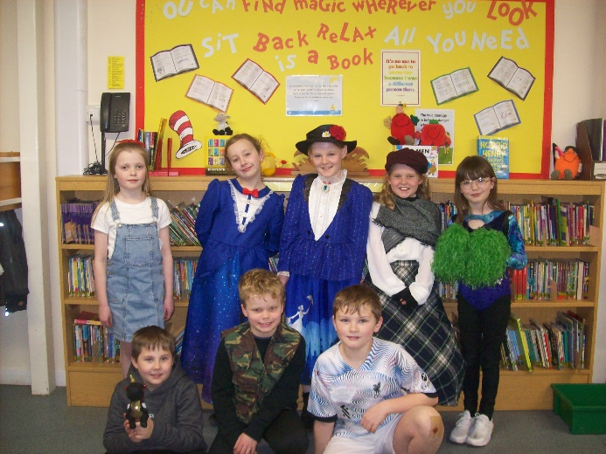

Over the years we have re-stocked the school library with the most up-to-date books for children to enjoy, purchased iPads for children to use in class and we have purchased an outdoor classroom for our Forest School area.

Contact email: [PTA@paulton-inf.bathnes.sch.uk](mailto:PTA@paulton-inf.bathnes.sch.uk)

**BEHAVIOUR MANAGEMENT**

The Behaviour Management Policy sets clear guidelines on expected behaviour and the appropriate measures for challenging unacceptable standards of behaviour. It also details how rewards are used to promote and recognise good behaviour.

In order to fulfil this policy all staff involved will be guided by the following principles:

* To expect high standards of behaviour at all times
* To be firm, fair and consistent at all times
* To encourage positive self-esteem through praise and reward systems
* To set a good example and provide a positive role model in a happy

and secure environment

* To provide the opportunities for children to be responsible for themselves

and others

**The School Rules**

* We will be kind and caring
* We will respect other people and their property
* We will try our best
* We will act safely and take care
* We will be responsible for our actions
* We will listen to and follow instructions from all members of staff immediately
* We will behave sensibly in all part of the school site
* We will only ever leave the school if we have permission

The policy sets out a selection of sanctions which may be used as part of the behaviour

management policy, these include:

* Warnings
* Yellow and Red Cards from SMSAs (Dinner Ladies)
* Isolation
* Removal of privileges
* Informal and Formal meetings with parents
* Home-School Books
* Referral to Senior Teacher
* Pupil Contract
* Daily Behaviour Report
* Debarment during the midday break
* Exclusion (fixed-term and permanent)

All staff at Paulton Junior School are designated with the authority to control and restrain children where necessary, this is in line with the Education Reform Act of 1997 (Section

550A). this will only be used where:

* Committing a criminal offence (including behaving in a way that would be an offence if the pupil were not under the age of criminal responsibility);
* Injuring themselves or others;
* Causing damage to property (including pupils own property);
* Engaging in behaviour prejudicial to maintaining good order and discipline at the school or among any of its pupils, whether that behaviour occurs in a classroom during a teaching session or elsewhere

**REWARDS**

In order to reinforce positive behaviour and effort the following rewards will be employed:

* Individual praise and encouragement;
* Appropriate written comments on work;
* Awarding of Certificates, Stickers, commendations and privileges;
* "Blue cards" from SMSAs (Dinner Ladies);
* Public commendations for good behaviour and work in Good Work and

general Assemblies;

* Positive communications with parents to share success;
* Recognition of public successes in the community;
* Golden Points;
* Building Success Wall.

**HOUSE TEAMS**

The school has a House Team System in place. Children will be placed within one of four Houses on arrival at the school, these are **Ash** (Blue), **Oak** (Yellow), **Beech** (Green) and **Elm** (Red) and Golden Points can be awarded by any member of staff for any positive behaviour, or academic achievement. A trophy for the team with the most points is awarded at the end of each half-term.

At the beginning of the year each House elects a Captain and a Vice-Captain from Year 6, these elected representatives have the responsibility of leading their House and organising some of the events which are run throughout the year.

**SCHOOL UNIFORM**

We have high expectations for our children and school uniform is an obvious symbol that children share these expectations, and have a pride in belonging to our school community. We therefore set a clear expectation that uniform will be worn. **Extremes of fashion are neither acceptable nor appropriate for school either** in **clothes**, **footwear**, or **hairstyle**. **Hair should be cut in an appropriate style for school** e.g. **no patterns shaved in to the hair.** **Shoes worn to school should be appropriate**. High heels and 'flip-flops' are not safe and should not be worn in school. Training shoes may be worn for PE **but must not be worn in place of shoes** as they can become an expensive and inappropriate fashion statement for some children.

**NAVY BLUE Sweatshirt or cardigan – with School Logo**

**GREY Trousers, Shorts, Skirt or Pinafore**

**BLUE & WHITE Gingham Dress**

**WHITE Shirt, Blouse or Polo Shirt (school logo polo shirts are available).**

**BLACK, NAVY OR GREY school socks**

**GREY Tights**

**NO COLOURED or PATTERNED TIGHTS or SOCKS**

**ONLY BLACK School Shoes**

**NO TRAINERS (except for sports)**

**NO BOOTS or HIGH HEELED SHOES**

**NO OPEN TOED SANDALS or FLIP- FLOPS**

**PE KIT**

* **PE T-SHIRT with school logo (House Colours)**

**ASH - blue**  **OAK - yellow BEECH - green ELM - red**

* **Black or navy PE shorts or skort**
* **Trainers (for PE)**
* **Tracksuit or joggers and sweatshirt (for outdoor PE lessons)**

**OUTDOOR LEARNING**

* **Wet weather gear – waterproof coat and trousers**

***On most days, children will spend time outside and will need adequate***

***clothing & footwear.***

* **Wellies**

**Uniform can be ordered through our school website** [**www.paultonjuniorschool.co.uk**](http://www.paultonjuniorschool.co.uk) **by clicking on the parents section then click on the uniform tab at the top of the page. Our uniform provider is Price & Buckland. Samples of all sizes of uniform are available to try on in our school office.**

***PLEASE MAKE SURE YOU NAME ALL ITEMS OF CLOTHING AND FOOTWEAR.***

**JEWELLERY/PERSONAL POSSESSIONS**

We want your child to be safe at all times, therefore, the wearing of jewellery is firmly discouraged. If a child has pierced ears stud earrings only may be worn (no other piercings are allowed), but we ask that these are removed for swimming and P.E. activities. Children will be asked to remove all other jewellery, which will be handed back at the end of the day.

Children should **not** bring any precious or valuable 'treasures' to school as we cannot take responsibility should they be lost or damaged.

**LOST PROPERTY**

Any lost or unnamed property is put in the school lost property box (located at the front of school) for several weeks for claiming. Any unclaimed items will be given to charity.

**Please make sure you name ALL items of clothing and footwear.**

**MOBILE PHONES**

All **mobile phones** must be handed to the school office at the start of the day and collected at home time. **Phones are not allowed to remain with children during the school day.**

**SCHOOL MEALS**

The most up to date information regarding school meals and a menu are available on our website.

Currently, we do not have a provision to offer hot school meals onsite (this is currently being reviewed). Therefore, **Packed Lunches** are required to be brought in by **ALL** children. These should be packed in a **small named container** with a close-fitting lid and clearly marked with the child's full name. If your child chooses to bring a packed lunch please ensure that it contains **no chocolate, sweets or fizzy drinks**. Please ensure children have water bottles of water in school. They may bring a drink in a carton or plastic bottle as part of the packed lunch too. **Absolutely NO nut products.**

**Free School meals vouchers** can be provided, to find out if you qualify please telephone BANES Free School Meals Team on 01225 394317 or **come into the School Office** for confidential advice and help to fill out the relevant forms.

We have a dedicated team of lunch-time assistants (SMSAs) who care for children during lunch-time. They work to keep your children safe and happy in the playground, and encourage good manners.

**MID-MORNING SNACK**

Your child may choose to bring fruit to school for consumption at break-time. It should be clearly named, in a suitable container if necessary.

**No crisps, chocolate or sweets should be brought to school for break-time snacks.**

**Absolutely NO nut products.**

**FIRST AID**

The School Nurse visits to carry out health inspections, vision and screening with parents' permission and will see parents on request.

If your child suffers a minor injury at school they are treated by a qualified first aider. If your child has a more serious accident or is ill in school, we will inform you immediately.

If a child has any form of first aid treatment a copy of the first aid slip will be sent home with the child outlining briefly what happened and the treatment given.

**PLEASE MAKE SURE AT ALL TIMES WE HAVE UP TO DATE INFORMATION ABOUT WHERE TO CONTACT YOU AND ALSO AN EMERGENCY CONTACT NUMBER SHOULD YOU BE UNAVAILABLE.**

If your child has a long-term condition, please come in to make special arrangements with the Headteacher.

**Please do not send your child to school if they are suffering from sickness for 48 hours after the last episode of vomiting or diarrhoea in order to stop the rapid spread of infection to other children and families.**

**SEVERE WEATHER**

Should the school be closed at any time, you will be informed via our texting service immediately. It will also be announced on the BANES website and on our school website. However, we will always endeavour to keep the school open.