clip_image001clip_image001

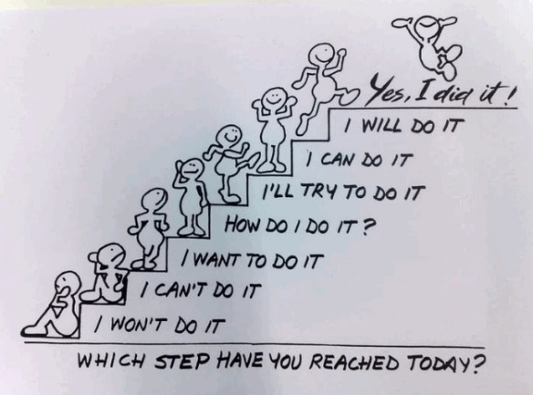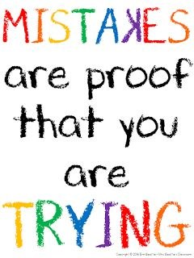

**Top Tips for Supporting Your Child’s English Skills at Home**

**Development of Reading**

Very few people are natural readers: reading is a skill, which needs to be taught and learned. Practice and enjoyment at home is crucial. Learning to read is a complicated process, which requires children to draw upon many skills.

Learning to read

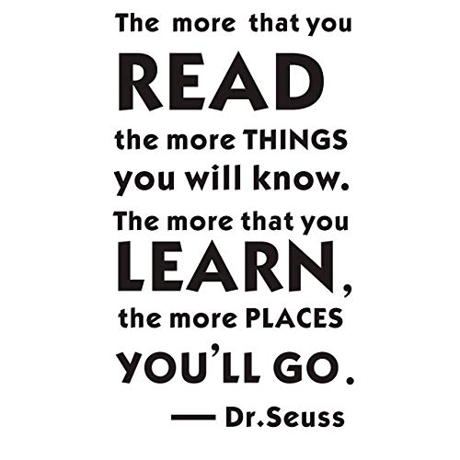Children begin by developing phonic (sound) skills to decode (break down) words and read texts. They also develop the ability to recognise familiar words in a sentence and use picture and context (sense and meaning) to help them understand what they are reading.

As children become more accurate and then fluent readers, they then need to develop their comprehension skills. These skills are vital in children becoming successful in truly understanding what they are reading.

You can help your child develop these skills by asking the following types of questions:

Literal Questions: these ask children to recall or find information that is directly stated in the text.

Deductive or Inferential Questions: these ask children to answer questions by ‘reading between the lines,’ going beyond the information given in the text and supporting their understanding using their own experiences.

Deductive: an understanding developed based on evidence from the text.

Inference: an interpretation that goes beyond the literal information given.

For example:

What colour is her coat? Literal

Why is she wearing a coat? Inference

Evaluative or Responsive Questions: these ask children to form their own opinions about the text and think about how a text achieves its purpose, why words have been used or explore links with other texts.

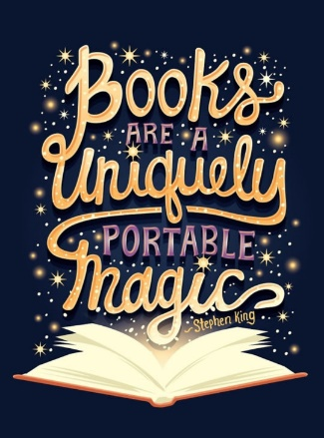

**Supporting Comprehension**

Comprehension is a key skill when reading. Use the following question starters/examples to develop different types of comprehension skills when reading with your child. These sample questions are in addition to the ones in your child’s reading record. Your child’s reading record is a vital home/school link that is filled with fun activities for children to complete.

Literal questions:

How? When? Where? What? Which? Who? Why?

Deductive Questions (Fiction)

Why is the title of the story Journeys?

How did your opinion of the wolf change as you read more of the story?

Why did Billy feel sad?

What would you have done if you had been there?

What do you think will happen next?

What do you like about the story, why?

Deductive Questions (Non-Fiction)

What is this book about?

What is this kind of leaflet?

What does the pictures tell you?

How can I find out about where penguins live?

Evaluative or Reponses Questions:

Encourage children to comment on the organisation or presentation of the text.

Why does author use the word unfamiliar?

Why is CRASH written in capital letters?

Does the way the words in the story are repeated remind you of any other stories?

What do you notice about the words Pretty Princess Penelope?



**Developing a love of Reading**

**Tips for motivating your child to read!**

Make reading a special time by reading in different places. E.g. Under a quilt with a torch, in the garden, make a den or even, under an umbrella!



Make reading FUN by turning it into a game. E.g. Have a code-word like ‘popcorn’ which signals you or your child to take over from reading. Have a little competition to spot words in your book like adjectives, nouns or verbs when you read.

Read alongside your child and let them see you read for pleasure. Agree to share something about your own books after you have both finished. For example, your favourite part or a new word that you have learned.

Variety is the spice of life! Read different things in addition to your school reading book. E.g. a comic, a picture book, a poetry, recipe book or menu. Let your child choose a book that interest them e.g. books about their hobbies.

Encourage your child by rewarding them with stickers – this can be arranged alongside their teacher too!

If your child is stuck on a word, encourage them to sound it out, use the pictures to help them or look at what has happened so far and put the word into context. It is also OK to tell them! Keep the experience a positive one!

Talk about books. Retell your favourite story or part of your book (both you and your child) or simply make up a story together based on a picture or a random object, for example, smelly socks!

**Developing Vocabulary**

Try these quick games when you are at home or out and about!

* Hangman
* Word Waterfall – write a random word at the top of your page e.g. table, underneath write a word associated with that word e.g cloth then underneath that a word associated with the word directly above. Play for 30 seconds. Can you put your first and last word into a sentence? Can you make your sentence funny or scary?
* Speedwriter – choose a random theme e.g Halloween. Your child has to write as much as they can joined up about the topic in 30 seconds without taking there pen off the page.
* Word Links – Start with a random word at the top of your page e.g. WORK and another word at the bottom e.g. WEAK. Can you get from one word to another by changing one letter at a time?
* Rhyme it – Think of a word e.g. feet. How many rhyming words can you think of in 30 seconds?
* Reveal – parents or child write the first letter of a word they are thinking of and the number of letters e.g. g \_ \_ \_ \_ Can you write down as many 5 letter words as you can think of beginning with G? Then the questioner reveals the 2nd letter and the guesser removes impossible words. Repeat until you find the word.
* Looking for words in words – letters have to remain in the correct order. E.g. beginning – be, beg and in.
* Word blocks – Draw a simple nine square grids containing a mixture of random consonants and vowels. How many words can you make? Who can make the longest word?
* Sentences – Use two words that do not go together e.g. shark and jelly (or you could do a verb and a noun). Create your silly sentence.



**Spelling Strategies**

Spellings in our school is taught using the No Nonsense Spelling Programme. The focus of the programme is on the *teaching* of spelling, which embraces knowledge of spelling conventions – patterns and rules; but integral to the teaching is the opportunity to promote the *learning* of spellings, including statutory words, common exceptions and personal spellings.

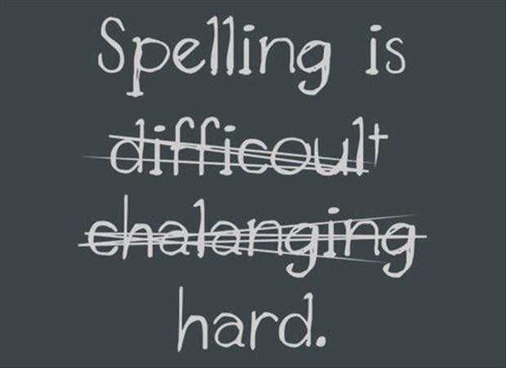

Exploring words can be lots of fun! Children love words being investigators and seeing how words relate to each other. Using a variety of strategies, such as Rainbow Writing, is a great visual tool for children to use to remember different letter strings e.g. bottle. Please see our No Nonsense strategies for parents to see how you can support your child with their spellings. Although we do not formally test your child’s spelling ability by sending 10 spellings home weekly, we assess them as part of our teaching sequence through dictations and other application methods.

