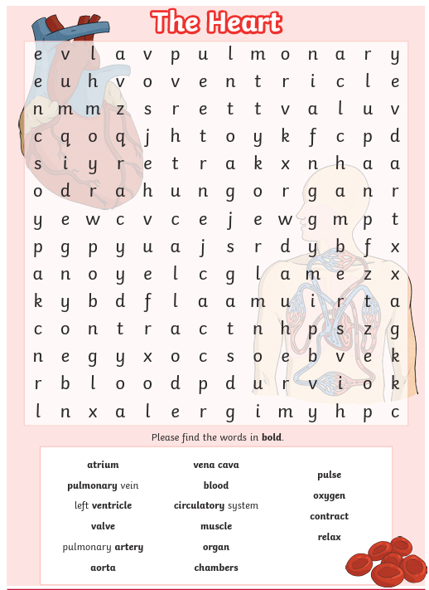
Create a fact file about the human heart on the plain paper you have been given. Include information you learnt in science and any further research you are able to do. Ensure your fact file is informative and written in your own words (not simply copied from a webpage or book). Check the spelling of all scientific words that you use. You may wish your fact file to include a mixture of writing and scientific diagrams. You may wish to use colour.

