
WedNESDAY 16TH jULY 2025
PAULTON JUNIOR SCHOOL
NEWSLETTER

Learning Together, Learning For Life
Our Paulton Junior School 6R Values
RESPECT RESOURCEFUL RESILIENCE REASONING RESPONSIBILITY REFLECTIVE

Diary Dates
Friday 18th July – Break up- Last day of Term 6
Monday 1st September – INSET Day (school closed)
Tuesday 2nd September – First day back to school Term 1
Friday 24th October – INSET DAY (school closed)
Thursday 23rd October - Break up - last day of Term 1
Monday 3rd November – Term 2 starts

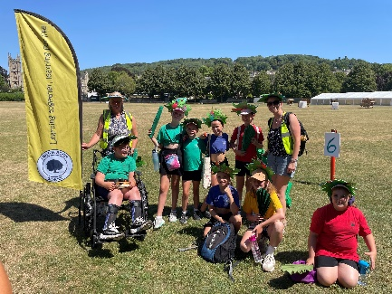
Year 5 Bath Carnival
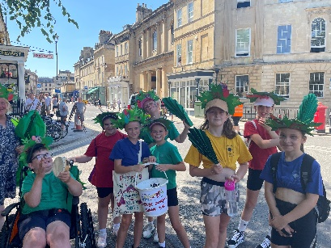


All of Year 5 were lucky enough to take part in a Carnival Day at school. We learnt all about the pitcher plant and the tree shrew and their symbiotic relationship. The pitcher plant is the shrew’s own little toilet!
We decorated our own shrews and learnt all about carnivals around the world and specifically Brazil and their famous Rio Carnival. We then learnt all about the Bath Carnival and how it includes people from all over BANES but also the world!
On Saturday 12th July in Bath, some of the Year 5 children represented Paulton Junior School in Bath’s very own Carnival! It was a fabulous day and the children thoroughly enjoyed themselves in the parade and coped very well with the very hot weather! Thanks to Mrs Goucher for organising this event – we look forward to the children getting involved again next year.

Year 6 Fly High with Mary Poppins Comes to Paulton!
Practically perfect in every way – that’s the only way to describe the unforgettable Year 6 production of Mary Poppins Comes to Paulton! From the very first “spit spot!” of auditions to the final bow, every single child showed extraordinary talent, dedication, and joy. They didn’t just act – they became their characters, learning lines, perfecting songs, mastering choreography, and sprinkling a little bit of magic (and maybe a spoonful of sugar) into every moment. The energy, enthusiasm, and effort they poured into this show was nothing short of supercalifragilisticexpialidocious!
We are bursting with pride at how confidently and brilliantly our children took to the stage, performing with such heart and humour that they truly left their mark on Paulton Junior School. The thunderous applause and tearful smiles from the audience said it all – this was a show we’ll never forget.
Behind the scenes, the magic continued. We are beyond grateful to our incredible production dream team – Mr Smith, Miss Richards, Mrs Pearson and Mrs Langan – whose tireless work, endless creativity and unwavering belief in the children turned a school hall into Cherry Tree Lane. From directing rehearsals to coaxing out every last bit of character, they truly went above and beyond – even when the wind changed direction!
A huge thank you must also go to our marvellous teaching assistants – Mrs Squires, Mrs Jones and Mrs Grainger – whose crafting skills and imagination helped bring the magical world of Mary Poppins to life. Whether painting props, building scenery, or raiding their own homes for costume pieces (alas, not from a bottomless carpet bag!), they were the wind beneath the production’s wings.
This production has been a shining example of teamwork, talent, and the joy of storytelling. It’s not every day you see chimney sweeps dancing across the stage or nannies floating in with umbrellas – but thanks to the sheer brilliance of our Year 6s and the dedication of every adult involved, we were transported into a world where anything can happen if you let it. What a way to say goodbye to Paulton Junior School – with laughter, magic, and a standing ovation. Bravo, Year 6 – you truly were practically perfect!
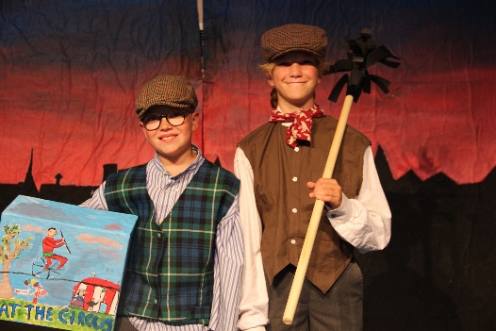
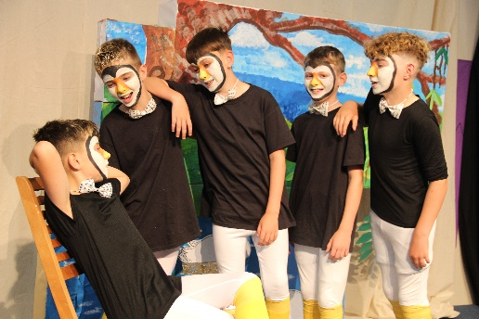
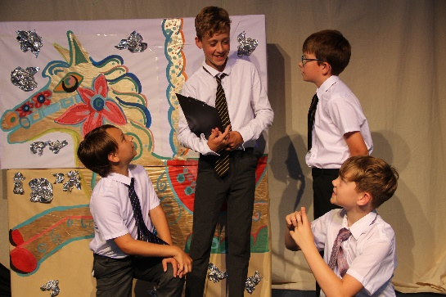
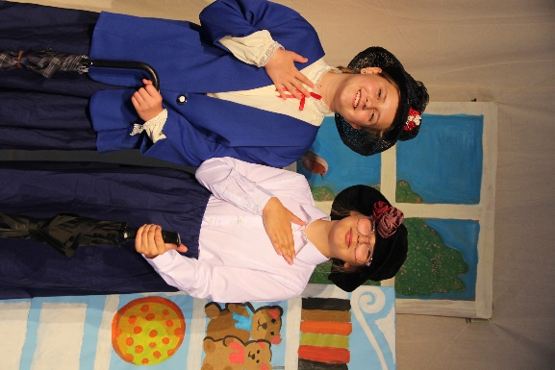

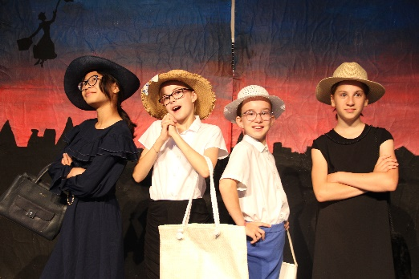



PTA
The Summer Fair raised an incredible £1800 Thank you once again for your continuous effort to raise the funds for our school PTA.
There will be updates about the Forest School Fundraising Campaign very soon!
Gardening Club
We are very proud to learn that Bath in Bloom have awarded us GOLD in the Schools competition. The children showed the two judges around the whole site and just WOWED them. Your children are amazing, they work so hard in the garden but they are also really good company and all get on so well together, helping each other and just being wonderful.
THANK YOU to every member of the gardening club team, your dedication and attention to detail got us our GOLD award. A huge thank you, also, to everyone who has supported us this year. You may have signed your children up to the club, bought plants or produce, attended our open garden event, bought a raffle ticket for the hanging baskets, bought a painted pebble or a potted hyacinth bulb or just walked around our garden and enjoyed it. You have enabled the gardening club to be self-sufficient again this year because all you have spent has bought more seeds, compost, gloves, plants and tools and we have not had to take any money from the school fund. What an achievement!
Bath in Bloom Painting Competition
Paulton Junior School have made a clean sweep in this competition again this year against child artists in the whole of Bath and North East Somerset age 7-11 category, winning the top 3 prizes and having 2 highly commended entrants as well. The winners will be announced in assembly. Haley Shackleton
Miss Moody and Mr Fox
We say our last good byes to Miss Moody and Mr Fox on Friday. As it was explained in the last newsletter, both members of staff have been with us for a few years covering maternity leave. We wish them both the best of luck- they will be missed, but hope they can come back to see us.
Mrs Craven
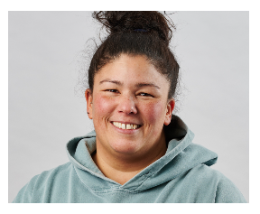
It is sad to say that …our wonderful Teaching Assistant and SMSA Mrs Craven is leaving us. She is such a supportive, caring and kind member of staff who contributes to our PJS team with enthusiasm, positivity and effort. She supports all the pupils academically, develops social and emotional skills through activities or play and is our qualified Forest School facilitator. Mrs Craven will be missed so much as she has also provided the interventions in Fundamental Movement. This involves developing physical skills including coordination, suppleness and balance in pupils. We wish her good luck for her next adventures as she starts working at the RUH.

Year 6 Basketball Tournament
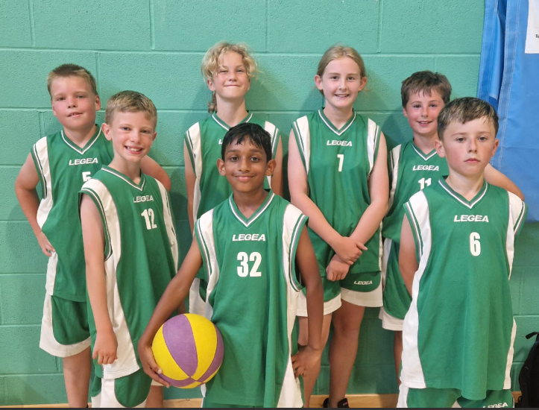
Last Thursday, we went to a basketball tournament with 7 other schools. It was run by Matt, our basketball coach, and he helped ref the games. We played 5 games in total; we lost 3, drew 1 and won one (with 8ft hoops). We won our only win 8-2 and our draw 6-6. William scored once, Felix scored three times and Charlie R scored four times, with great blocks and tackles from Phoebe, Sophie, Jeron and Alfie J. Overall, we all enjoyed the experience and learnt lots of new information about basketball.
Year 4 Ukulele Concert Celebration - Wednesday 9th July
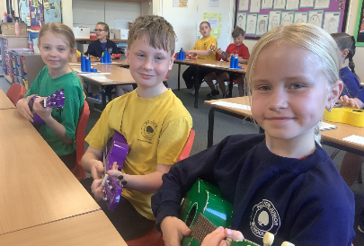
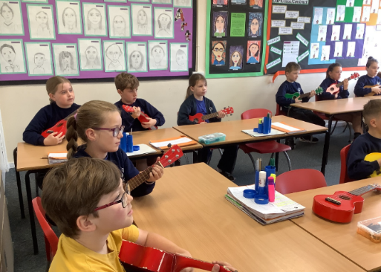
Over the past two terms, Year 4 pupils have been learning to play the ukulele in their Music lessons, provided by West of England Music and Arts (WEMA) Music Service. Last week, they had the exciting opportunity to showcase their progress in a fantastic ukulele concert. Performing a range of songs and demonstrating their growing confidence with a variety of notes, the children certainly impressed us! Parents and carers were warmly welcomed to enjoy the performance, which was a joyful celebration of the children’s hard work and superb progress. Well done Year 4!

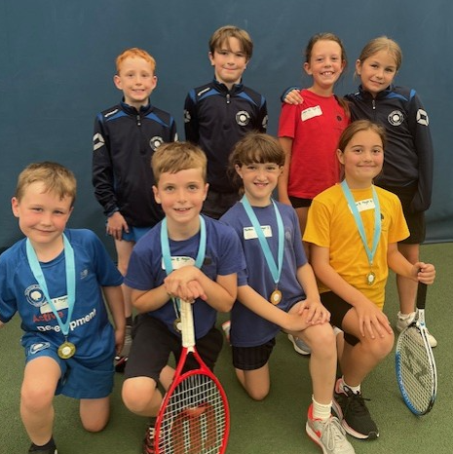
Year 3 and 4 Tennis Tournament CHAMPIONS!
Eight children represented the school at the tennis tournament at Writhlington Tennis Centre. All the pupils had to play singles matches and all their points were added together and really developed their tennis skills and confidence as they played their matches. The players went through to a play off and the final and were so focused. The Final was very competitive, with like abilities strategically placing shots and rallying out the points. Paulton Junior School B Team were crowned the overall WINNERS of the tournament. CONGRATULATIONS to Solly, Reuben, Emma and Alice. Max, Willow, Darcie and Ralph won their playoff.

Year 3 & 4 Quad Kids
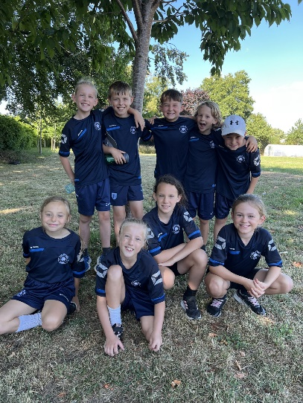
A group of enthusiastic Year 3 and 4 children recently visited St Benedict's School to take part in an exciting Quad Kids event. Competing in running, jumping and throwing activities, the children showed fantastic energy, teamwork and determination. We were proud to finish 9th out of 14 schools and even more thrilled that some of our pupils beat previous running records! Well done to everyone who took part and represented Paulton Junior School so brilliantly.
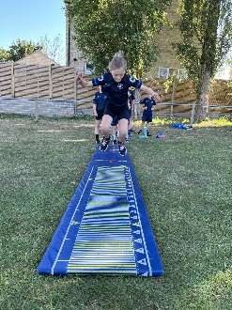
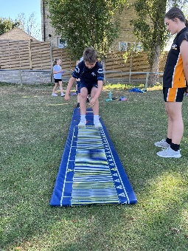

Holburne Museum, Bath
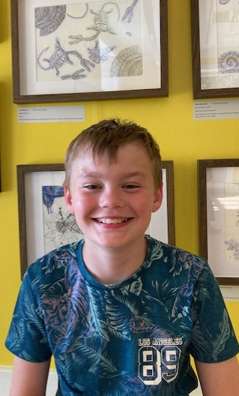
Twelve children from Year Six were chosen for their artistic talent to create artwork for the ‘I Spy With My Little Eye’ exhibition taking place, over the summer, at The Holburne Museum, Bath. Parents and children were proud to be invited to the museum and see the fantastic pictures on display last week. A huge congratulations to: George A, Daisy B, Leo B, Daisy S, Juke R, Salem R, Jemima T, Chloe C, Alice B, Alizah H, Jaylin B and Evie T. Thank you to Mrs Pearson who has continues to liaise with the museum and organise these wonderful, aspiring opportunities for the pupils at Paulton Juniors. We will be continuing our partnership with The Holburne
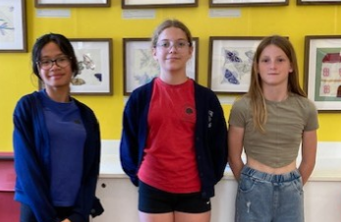

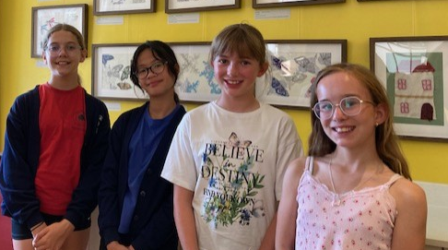
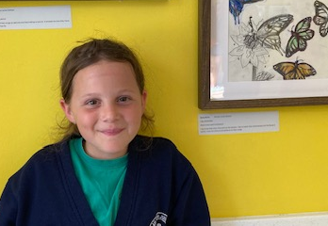

HOLIDAY EVENTS
Bikeability Learn to Ride summer training.
B&NES have informed us that
This module is for children who can’t ride a bike, aged between aged between 7 to 16 years old.

To reserve* a place, parents or guardians can fill our form HERE

Course | Learn to ride training
Cost | £15 per rider
Duration | Two sessions of 45 minutes
Bike & helmet loan | Available and free of charge
Location | Odd Down Sport Ground cycle track  Chelwood Road, Bath BA2 2PR
Dates available | - Wednesday 30 and Thursday 31 July  - Tuesday 12 and Wednesday 13 August
Time slots available | - 10:00-10:45  - 11:00-11:45  - 13:00-13:45  - 14:00-14:45
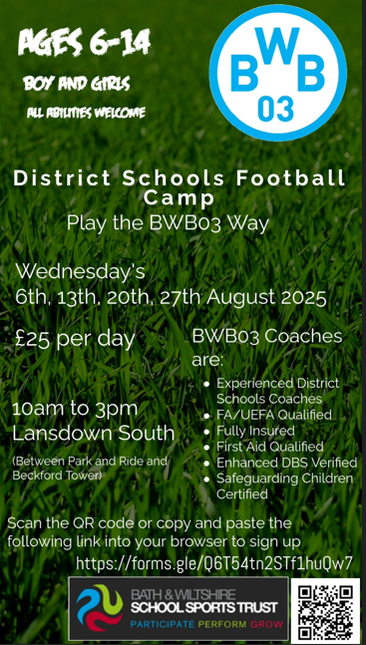


Year 6 SATs Results
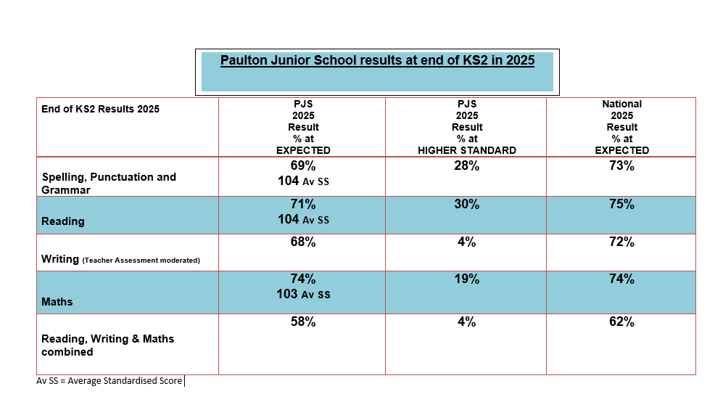
Year 4 Multiplication Times Table Check MTC Results 2025
In June the Year 4 children made a fantastic effort to learn and recall times table facts for the MTC test. As a year group they are performing significantly above in comparison to national data.
% pupils scoring 25/25 full marks | 66%
% pupils scoring 20 + marks | 91%

We wish the Year 6 the best of luck, as they leave Paulton Junior School. We hope everyone has happy memories and feel ready for their next adventures.
Have a wonderful summer break; the staff all look forward to seeing you on Tuesday 2nd September 2025.
Happy holidays everyone.


