 |  | Term 1 | Term 2 | Term 3 | Term 4 | Term 5 | Term 6
Year 3 | Key Texts | Monkey Puzzle by Julia Donaldson  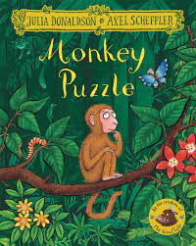  Owl Babies by Martin Waddell  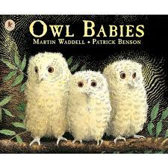  The Owl who is Afraid of the Dark by Jill Tomlinson  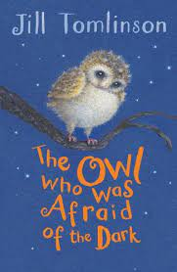 | Hodgeheg by Dick King-Smith  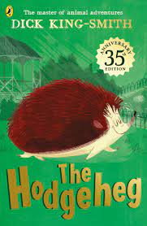  Here We Are by Oliver Jeffers  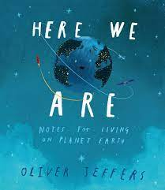  The Day the Crayons Quit by Oliver Jeffers  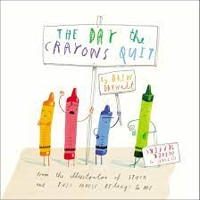 | Into The Jungle by Katherine Rundell  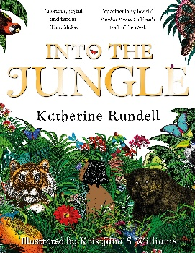 | The Magic Finger by Roald Dahl  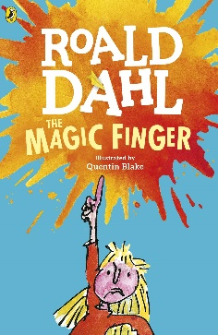 | The Boy Who Grew Dragons by Andy Shepherd  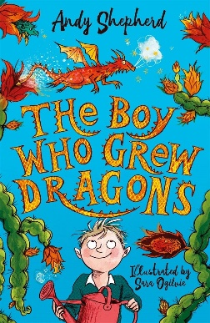 | Stuart Little by E. B White  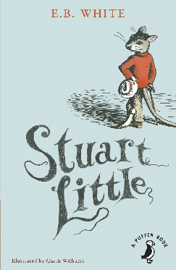  Non-Fiction – Linked to Coasts
Year 3 | Supporting Texts Used in Class to Aid Learning | Non-Fiction Texts about Owls  Rhyming Poetry | Tilly and the Time Machine by Adrian Edmonson  Pandora’s Box | The Jungle Book by Rudyard Kipling  Shape Poetry  Kenning Poems  Instructions | Explanation Texts for Analysis | Aesop’s Fables including The Hare and The Tortoise and The Lion and the Mouse Fable | Kensuke’s Kingdom by Michael Morpurgo Extract  Mordiford Dragon Story
Year 3 | Topics to Research and Read Non-Fiction Information About | The Stone Age, Christianity, Owls, Rugby, Rocks and Minerals, Changes, Djembe Drumming, Gymnastics, Colour Mixing and Sketching | Stop Frame Animation, Design, Climate and Biomes, Anti-Bullying, Famous Scientists and Inventors (Marie Curie and Mary Anning), Soil, Basketball and Gymnastics and Christianity | Dance, Globes and Maps, Mindfulness and Wellbeing, Hinduism, Forces and Magnets, Sequencing Sounds, Netball, Himalayan Art, Batik and Henna Designs, The Bronze Age and The Stone Age | Data Bases, Healthy Eating, My Body, Hinduism, Animals (including humans), Badminton, Football, and Our World | Local History, Diverse Britain, Islam, Desktop Publishing, Athletics, Swimming, Textiles and Plants | Gaudi and Mosaics, Coasts, Aiming High, Light, Programming, Cricket and Swimming
Year 3 | Linked Texts or Appropriate Reading for Pleasure Recommendations | Stone Age Boy by Satoshi Kitamura  Wolf Brother by Michelle Paver  National Geographic Readers: Rocks and Minerals  Spike Milligan Poetry  How to Wash A Woolly Mammoth by Michelle Robinson & Kate Hindley  24 Hours in the Stone Age by Lan Cook | Little People, Big Dreams: Mary Anning and Marie Curie  Women in Science by Rachel Ignotofsky  Scientists are Saving the Wolrd by Saskia Gwinn  Leonora Bolt Secret Inventor by Lucy Brandt | Step Up with Science: Forces and Magnets by Peter Riley  The Best Diwali Ever by Sonali Shah  The First Drawings by Mordicai Gerstein  Explore! Stone, Bronze and Iron Ages by Sonya Newland | See Inside Your Body by Katie Daynes  Lift-The-Flap How Your Body Works: 1 by Roskie Dickins  Asha & The Spirit Bird by Jasbinder Bilan  Little People, Big Dreams – David Attenborough by Maria Vegara  The Bee Book by Charlotte Milner  The Most Important Animal of All by Penny Worms  Greta and The Giants by Frances Lincoln Children’s Books | Rumaysa: A Fairytale by Radiya Hafiza  Planet Omar by Zanib Mian  The Big Book of Blooms by Yuval Zommer  The Bad Seed by Jory John | Flashlight by Lizi Boyd  Light by Georgia Amson-Bradshaw  The History of the Computer by Rachel Ignotofsky  100 Things to Know about Numbers, Computers & Coding

Year 4 | Key Texts | The Miraculous Journey of Edward Tulane by Kate DiCamillo  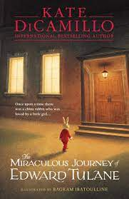  Fantastic Mr Fox by Roald Dahl  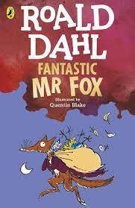 | Charlotte’s Web by E.B.White  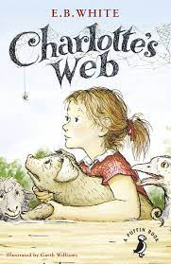  Matilda by Roald Dahl  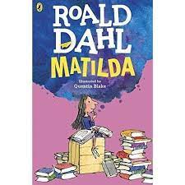 | The Journey by Aaron Becker  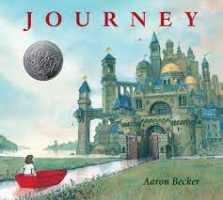  The Lion, The Witch and The Wardrobe by CS Lewis  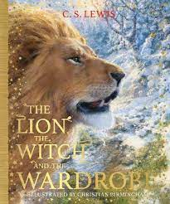  Jeremy Strong – 100 Mile an Hour Dog 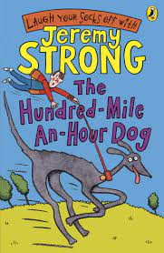 | The Wolves of Currumpaw by William Grill  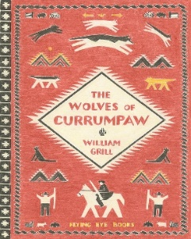  The Captive Celt by Terry Deary 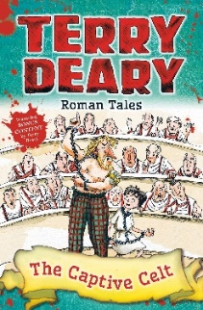 | Africa is Not a Country  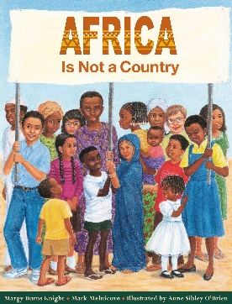  Mufaro’s Daughter by John Steptoe  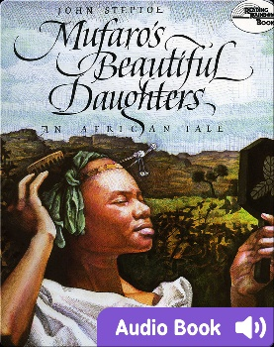 | 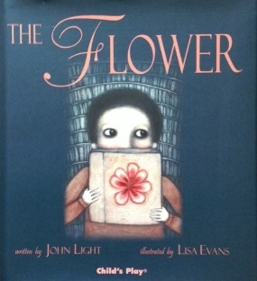 The Flower by John Light
 | Supporting Texts Used in Class to Aid Learning | Song Lyrics: Nina Simone, City Jungle, The Eagle by Tennyson  Non-Fiction on Foxes  Banksy Diary Entry  Poetry (Similes, Rhyming and Haikus) | Performance Poetry: Fireworks, Rain, The  Boneyard Rap, Harvest Moon The Gruffalo by Julia Donaldson  Explanation Texts: Food Chains, Plant Growth, Volcanoes, Mummification  Non-Fiction Information about Ancient Egyptians and Tutankhamun | Alice in Wonderland Lewis Carroll  Far-Flying Adventures of Fergus Crane Paul Stewart and Chris Riddell  Tom’s Midnight Garden by Phillippa Pearce  The Hobbit Part One JRR Tolkien  Fairy Lake Mythical Creatures Narrative |  | Tales from Africa: Why the Sun and the Moon Live In the Sky  Mountains Non-Fiction  Woodland Magic Poetry  Space Man Song Lyrics  Balanced Argument Analysis: Chocolate, Wonka Factory and School Chairs being banned. | Instructional Writing  Antarctic Adventures Non-Fiction  Oliver Twist Playscript
Year 4 | Supporting Texts Used in Class to Aid Learning (Continued) |  | Non-Chronological Reports Christmas and Sharks  Little Jack Egyptian Story | Non-Fiction Texts: River Talk and Eating and Digestion, Chines  Poetry: Magic Box by Kit Write, Me – Pirate by Clive Sanson and The Sound Collector by Roger Mc G, The Ning Nang Nong by Spike Milligan, Mrs Butler by Allan Ahlberg, The Dentist and the Crocodile by Roald Dahl, Others by Unknown, The Little Things by Margaret Lindsey, To Lift Each Other by Wes Fessler, Kindness by Kate Buxbaun
Year 4 | Topics to Research and Read Non-Fiction Information About | Kandinkski, Van Gogh, The Americas, Antibullying, Judaism, Christianity, Living Things and their Habitats, Relationships, The Internet and Exploring Networks | Ancient Egyptians, Pop Up Books, Digital Wellbeing, Audio Editing, Handball, Gymnastics, Judaism, Mindfulness and Wellbeing, States of Matter | Rivers, Insects, Computer Programming, Health and Safety, Christianity, Digestive System, Safety, Animals Including Humans, Multiskills, Swimming, Charcoal, Printing, Anti-Bullying and The Water Cycle | Photo Editing, Roman Britain, Growing Up, Humanism and Christianity and Electrical Circuits and Torches | Sculpting (Barbara Hepworth), Coding, Earthquakes and Volcanoes, One World, Sikhism, Athletics, Dance, Photo Editing and Sound | Seasonal Food, Data, Crime and Punishment, Money, Sikhism, Scientists and Inventors, Cricket and Athletics
Year 4 | Linked Texts or Appropriate Reading for Pleasure Recommendations | Mapping North America by Paul Rockett  The Noisy Paint Box by Barb Rosenstock  The Met Vincent Van Gogh: He Saw the Wolrld in Vibrant Colours by Amy Guglielmo | The Ancient Egypt Sleepover by Stephen Davies  The Heart Scarab by Saviour Pirotta  Marcy and the Riddle of the Sphinx by Joe Todd-Stanton  Pop-Up Books i.e. Alice’s Adventures in Wonderland by Robert Sabuda  The Eygptian Cinerella by Shirley Climo  Marcy and the Riddle of the Sphinx by Joe Todd Stanton | Once Upon a Raindrop Poetry by James Carter  The River: An Epic Journey to the Sea by Patricia Hegarty  Coding Games in Scratch by Jon Woodcock  Evelyn the Adventurous Entomologist: The True Story of a World-Traveling Bug Hunter by Christine Evans  Kay’s Anatomy by Adam Kay  Amy Gets Eaten by Adam Kay and Henry Paker  Gut Garden by Katie Brosnan | Queen of Darkness by Tony Bradman  You Can Take Amazing Photos by Lillian Spibey  The Journal of Iliona by Richard Platt  Empire’s End – A Roman Story by Leila Rasheed  Arthur High King of Britain by Michael Morpurgo | Earth Shattering Events by Sophie Williams  A Bear Grylls Adventure: The Earthquake Challenge  Look Inside Volcanoes and Earthquakes by Laura Cowan  When the Mountains Roared by Jess Butterworth  Sounds All Around: The Science of How Sound Works by Kids Can Press | The Highwayman by Alfred Noyes  Treason by Berlie Doherty  Black Powder by Ally Sherrick  The Secret Diary of Kitty Cask – Smuggler’s Daughter by Philip Ardagh and Jamie Littler  Dick Turpin: Legends and Lies by Terry Deary  The Adventures of Robin Hood by Marcia Williams

Year 5 | Key Texts | The Seal Children by Jackie Morris  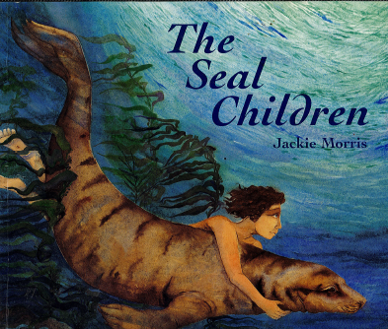  Can you catch a mermaid? By Jane Ray  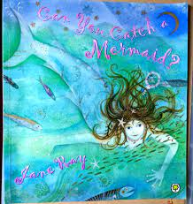  The Spiders Web (Greek Mythology)  Beowulf Adapted by Michael Morpurgo  Arthur and the Golden Rope by Joe Todd Stanton  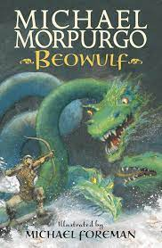 | Journey to Jo’Burg by Beverley Naidoo  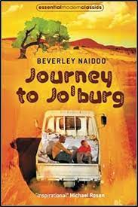  Who Let the Gods Out? By Maz Evans  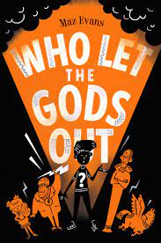 | The Iron Man by Ted Hughes  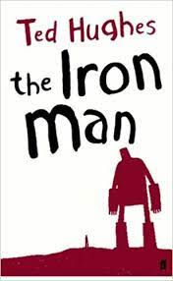  Little Guides to Great Lives: Stephen Hawking by Isabel Thomas  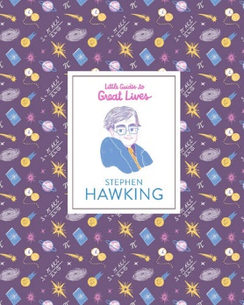 | Cosmic by Frank Cottrell  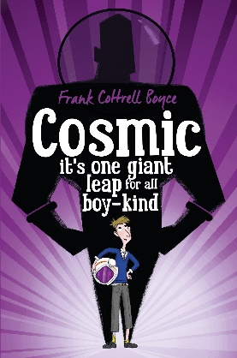 | The Explorer Extract by Katherine Rundell  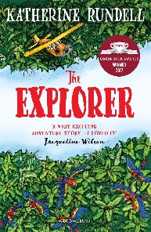  Journey to the River Sea Extract by Eva Ibbotson  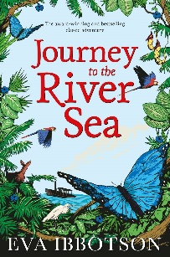  Cicada by Shaun Tan  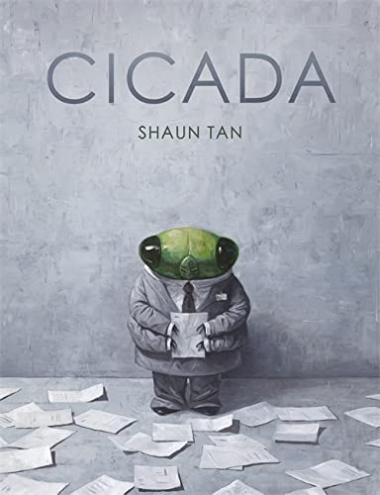 | Lyrics and Scripts from Musical Theatre and Popular Songs - I have a Dream from Tangled; Be Prepared by Sia; The Hunchback of Notre Dame; Mary Poppins
Year 5 | Supporting Texts Used in Class to Aid Learning | Cogheart by Peter Bunzl, The Clockwork Crow by Catherine Fisher, Spud Murphy by Eoin Colfer and Storm Keeper’s Island by Catherine Doyle  Theseus and the Minotaur  Song Lyrics: DragonSlayer and When I Grow Up | Poetry: ‘A Matter of Holes’ by Grace Nichols, Sir Autumn, The Satyr’s Head, The Language of the Cat, Daffodils, ‘Personal Helicon’ by Seamus Heaney, read ‘Sir Autumn’ by Grace Nichols, It’s Bonfire Night by Kevin McCann, Nightwriter by Tony Mitton, Halloween’s Crumble by Joseph Coelho, Six Facts About by Rachel Rooney and Fishing by Rachel Rooney, Quicksilver by Roger McGough, I am a Writer by Joseph Coelho  Here We Are by Oliver Jeffers | Non-Fiction Texts about Space and The Big Book of Space | Sea Myths The Kraken, Merfolk and Selkies and Sirens  The Jabberwocky Poem  Long, Lone Selkie Poem  Diaries: Diary of a Wimpy Kid and Work House by Pamela Oldfield, The Life of a Paperclip and an Astronaut’s diary | Zoo by Anthony Browne  Circle of Life Lyrics  Life Cycle of a Butterfly  Beetle Non-Fiction and Beetle Boy by M.G.Leonard  Test Style Questions: Layers of the Rainforests Text, Animals in Zoos Text and The Great Kapock Tree  Poetry: Joseph Coelho (Golden Time, Ruby Red Rings and The Highwayman by Alfred Noyes | Disney  Modern – Peter Pan and Wendy  Children’s Classics – The Firebird  William Shakespeare – Romeo and Juliet
Year 5 | Topics to Research and Read Non-Fiction Information About | Michaelangelo Leonardo Da Vinci, Observational Drawing, Christianity, Anglo-Saxons, Islam, Properties and Changes of Matter, Relationships, Computer Systems, Tag Rugby and Swimming | Video Editing, Building Bridges, Paulton Local Study, Ukelele, Being Yourself, Media, Swimming, Gymnastics, Building Bridges and Structures, Jazz and Forces | Positivity, Earth and Space, Physical Computing, Dance, Netball, Portraits and Colour Mixing, The Vikings and Hinduism | My Body, Scientists and Inventors, Creating Media, Gymnastics, Tennis, Moving Mechanical Toys, Europe and The Alps and Hinduism | Journeys, Diverse Britain, Living Things and Their Habitats, Basketball, Rainforest Art, Observational Drawing and Painting and Islam | Masks, Journeys and Trade, Islam, Animals (including humans), Athletics, Basketball, Bread and Aiming High
Year 5 | Linked Texts or Appropriate Reading for Pleasure Recommendations | Myths and Legends  Michaelangelo for Kids by Simonetta Carr  Leonardo da Vinci’s Life of Invention by Jake Williams  Anglo-Saxon Boy by Tony Bradman  King Arther and the Knights of the Round Table by Marcia Williams  Men, Women and Children in Anglo-Saxon Times by Jane Bingham | Give it a push! Give it a pull! A look at forces by Jennifer Boothroyd  Forces by Joanna Brundle | The Polar Bear Explorer’s Club by Alex Bell  Feelings: Inside my heart and my head by Libby Waldon  The Kid Who Came from Sapce by Ross Welford  Dear Earth by Isabel Otter  The Cosmic Diary of Our Incredible Universe by Tim Peake  Knowledge Encyclopedia Space! By DK | The Great Kapok Tree by Lynne Cherry  The Girl who Thought In Pictures by Julia Mosca  Lost in the Toy Museum by David Lucas  The Story Machine by Tom McLaughlin  Rosie Revere Engineer by Andrea Beaty  See Inside How Things Work by Conrad Mason | The Boy at the Back of the Class by Onjali Rauf  An English Year: Twelve Months in the Life of England’s Kids by Tania McCartney  Little Badman and the Invasion of the Killer Aunties by Humza Arshad & Henry White  Danny Chung Does Not Do Maths by Maisie Chan | Explore! Fair Trade by Jillian Powell  The Incredible Journey by Sheila Burnford  Where the World Turns Wild by Nicola Penfold  Everybody’s Wlcome by Patricia Hegarty  An Anthology of Intriguing Animals by DK and Ben Hoare
Year 6 | Key Texts | Holes by Louis Sachar  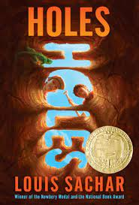  Clockwork by Philip Pullman  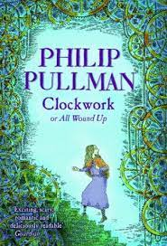 | Cogheart by Peter Bunzl  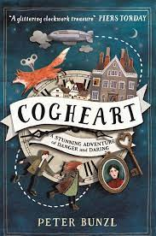  The Nowhere Emporium by Ross Mackenzie  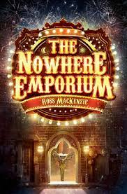 | The Malamander by Thomas Taylor  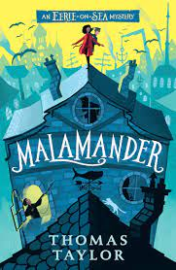  Poetry – The Refugees by Brian Bilston  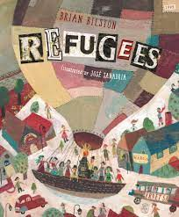 | The Emergency Zoo by Miriam Halahmy  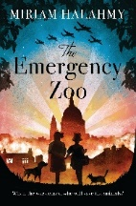  Goodnight Mr Tom by Michelle Magorian  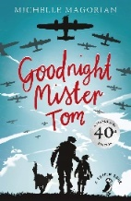  War Horse by Michael Morpurgo Extract  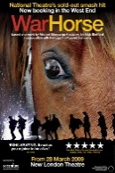 | Elon Musk Non-Fiction Text  Evolution Non-Fiction Text  Escape from Pompee by Christina Balit  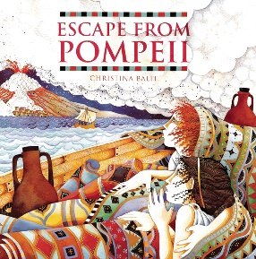 | Beetle Boy by M. G Leonard  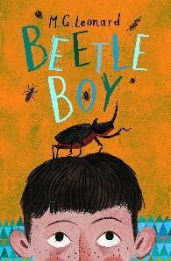  A Place Called Perfect by Helena Duggan  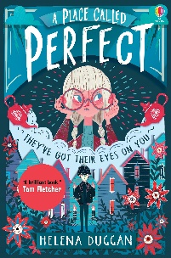
Year 6 | Supporting Texts Used in Class to Aid Learning | Non-Fiction Information about Black History Month  Non-Fiction Reading about Science: Living Things and Their Habitats  Explanation Texts  Various Story Settings  Haikus and Tankas | Non-Fiction Information on Robots  Non-Fiction information about Greta Thunberg and Martin Luther King (including from Little People, Big Dreams Collection) and Famous Speeches  Persuasive Writing  Non-Fiction about the Environment  Non-Fiction Information on the Christmas Truce | Non-Fiction Texts about the Titanic  The Mysteries of Harris Burdick by Chris Van Allsburg  Newspaper Reports | WWII and Anne Frank – Information Text and Diary Extracts | SATs Appropriate Texts | Non-Fiction on Buddhism  The Arrival by Shaun Tan  Production Script  Orphans of the Tide by Struan Murray
Year 6 | Topics to Research and Read Non-Fiction Information About | South America and The Amazon, Judaism, Living Things and Their Habitats, Internet Connection, Touch Rugby, Swimming, Observational Drawing | Global Warming and Climate Change, Football, Gymnastics, Textiles, Digital Wellbeing, Judaism, Animals (including humans), Web Page Creation | Dance, Netball, Perspective, Computer Programming, The Maya Civilisation, Health and Safety, Christianity, Evolution and Inheritance | World War II, Electrical Systems, Growing Up, Christianity, Fitness, Hockey, Hinduism and Light | One World, Athletics, Basketball, Set and Prop Design, 3D Modelling, The Greeks, Buddhism and Electricity | Great British Dishes, Our World, Money, Buddhism, Scientists and Inventors, Transition, Spreadsheets
Year 6 | Linked Texts or Appropriate Reading for Pleasure Recommendations | The Explorer by Katherine Rundell  Cinnamon by Neil Gaiman  The Wild Way Home by Sophie Kirtley  Journey to the River Sea by Eva Ibbotson  Running Wild by Michael Morpurgo  The Incredible Ecosystems of Planet Earth by Rachel Ignotofsky  The Great Kapock Tree by Lynne Cherry | Little People, Big Dreams – David Attenborough  Pig Heart Boy by Malory Blackman  Kay’s Anatomy by Adam Kay  The Cogheart Series by Peter Bunzl  The Nowhere Emporium Series by Peter Bunzl  Where the World Turns Wilde by Nicola Penfold  Last The Story of a White Rhino by Nicola Davies | No Ballet Shoes in Syria by Catherine Bruton  The Boy at the Back of the Class by Onjali Q Rauf  The Origin of Species by Sabina Radeva  Amazing Evolution: The Journey of Life by Anna Claybourne  Moth: An Evolution Story by Isabel Thomas  National Geographic Readers: Titanic  The Boy at the Back of the Class by Onjali Raug  On the Move by Michael Rosen  Oh Maya Gods by Maz Evans  Darwin’s Dragons by Lindsay Galvin | Carrie’s War by Nina Bawden  When the Sky Falls by Phil Earle  The Skylarks’ War by Hilary McKay  The Machine Gunners by Robert Westall  Letters from the Lighthouse by Emma Carroll  The Valley of Lost Secrets by Lesley Parr  My Secret War Diary by Marcia Williams  See Inside the Second World War by Rob Lloyd Jones | Leo and the Gorgon’s Curse by Joe Todd-Stanton  Theseus and the Minotaur by Sonia Elisabetta Corvagalia  Hercules by Sonia Elisabetta Corvagalia  Can You See Me? By Libby Scott  The Boy with the Butterfly Mind by Victoria Williamson  Cool Circuits and Wicked Wires by Susan Martineau  Great Lives in Graphics: Nikola Tesla by GMC Editors | Being Miss Nobody by Tamsin Winter  The Last Bear by Hannah Gold  Boy in the Tower by Penny Ho-Yen  The Island At the End of Everything by Kiran Milwood Hargrave  Why Money Matters by Deborah Meaden  Nadiya’s Bake Me a Story by Nadiya Hussain

